Horizontal scaling

Horizontal Scaling in Kubernetes
- In Kubernetes, horizontal scaling means increasing the number of Pods to handle more traffic or workload.
It is one of the core features of Kubernetes.
- Kubernetes scales applications horizontally by adding more Pod replicas.
Instead of making a single Pod bigger, Kubernetes creates more Pods and spreads them across Nodes.
Metrics Server installed and working:
kubectl apply -f https://github.com/kubernetes-sigs/metrics-server/releases/latest/download/components.yaml
kubectl -n kube-system edit deployments.apps metrics-server
spec:
containers:
- args:
- /metrics-server
- --kubelet-insecure-tls
- --kubelet-preferred-address-types=InternalIP

Check metrics are available:
kubectl top nodes
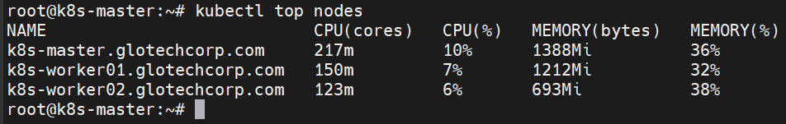

kubectl top pods
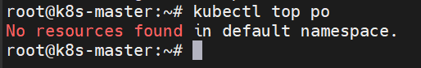
Deploy a Sample App with CPU Requests and Limits
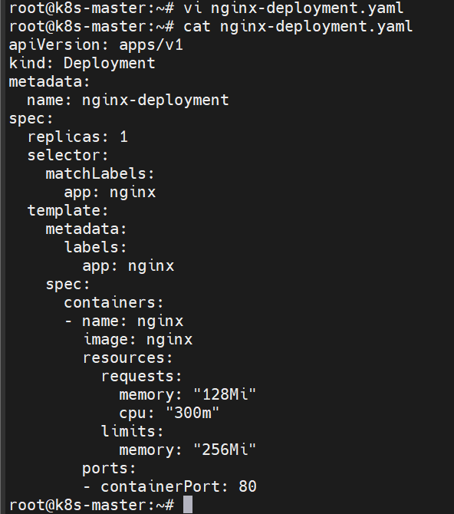
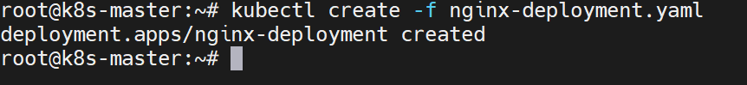
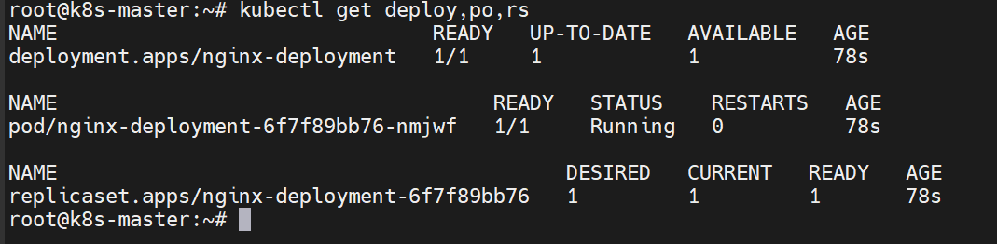
To view the cpu ,memory and limits:
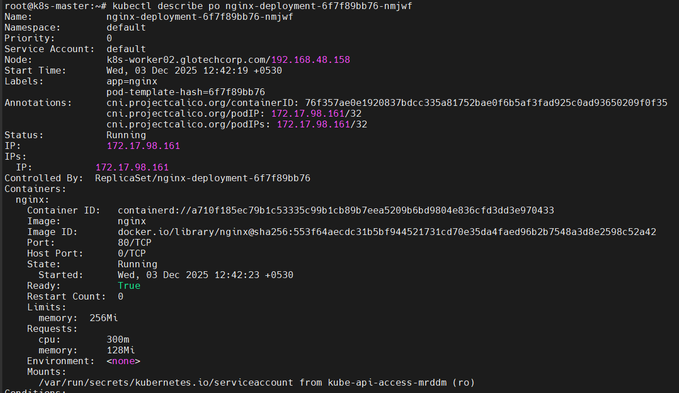
To view the top pod:
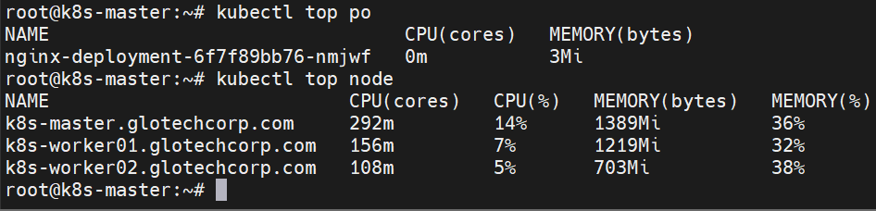
Create an HPA:
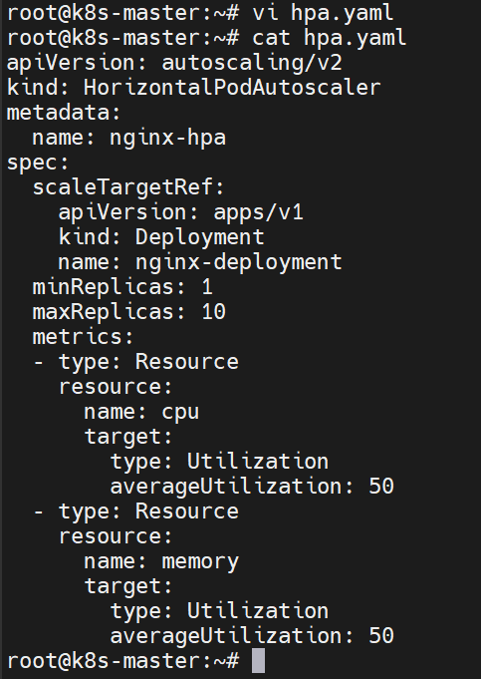
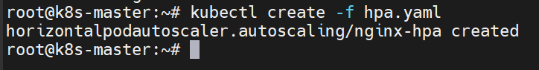
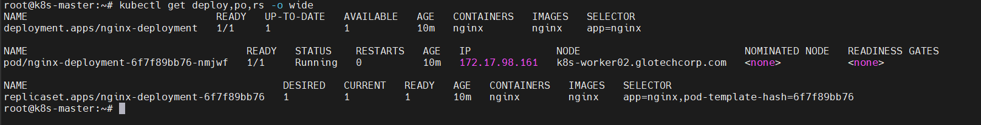
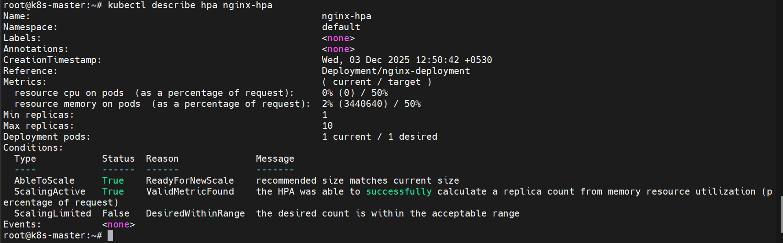
If pod utilization increase menas automatically extent the pods
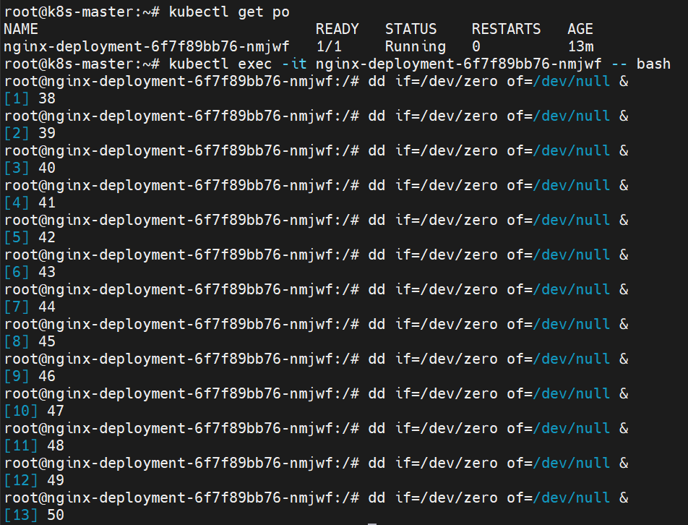
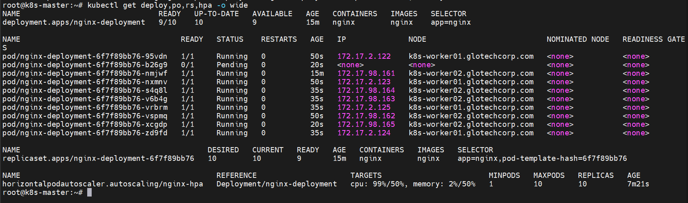
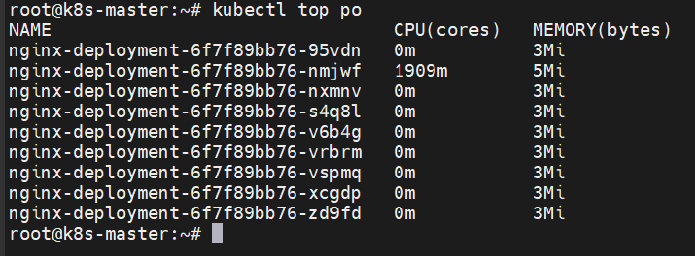
======================================================================
Horizontal Pod Autoscaler
Horizontal Pod Autoscaler (HPA) automatically adjusts the number of pods in a Deployment based on CPU utilization.
If the CPU usage of the pods decreases below the target value, HPA automatically scales down by deleting extra pods to save resources.
If the CPU usage increases above the target value, HPA automatically scales up by creating new pods to handle the load.

